Assignment 1
Matthew Shaver | UNCC Email ID: mshaver5

Dataset Preparation
The Dogs vs. Cats dataset was downloaded from Kaggle, and the photos were already organized into training, validation, and testing folders. While preparing the data and starting the training process, I realized that some image files couldn't be loaded correctly. These files appeared to be corrupted or unusable, so I included a cleaning phase to identify and remove them before proceeding. After eliminating the problematic files, the notebook checked the class counts for each dataset split to ensure that the cleaned data was ready for preprocessing and modeling.
Split | Cats | Dogs | Total
Training | 9,977 | 9,963 | 19,940
Validation | 1,247 | 1,244 | 2,491
Test | 1,247 | 1,246 | 2,493

Preprocessing and Augmentation
Each image was scaled to 224 by 224 pixels to match MobileNetV2's input size and ensure that the model could handle it consistently. After resizing, augmentation was employed to significantly alter the training images, allowing the model to learn larger patterns rather than memorizing individual examples. The built-in TensorFlow pipeline used horizontal flipping, random rotation, and random contrast variations to imitate natural alterations in image direction, placement, and lighting. The custom ImageLoader took the same general strategy, but instead of relying solely on TensorFlow's built-in capabilities, it employed PIL-based transformations to manually make identical changes during training.
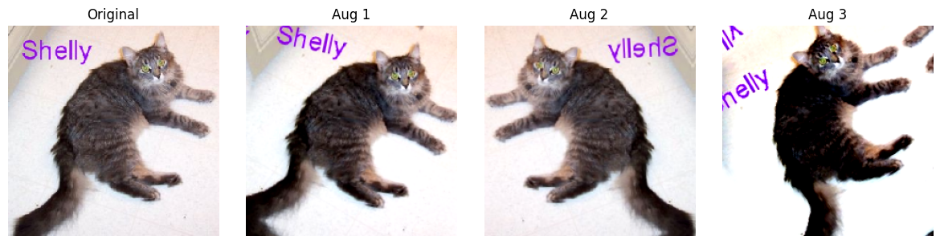
Screenshot 1. Example image augmentations from the newly run notebook.

Model Building and Training Steps
Step 1 - Load data: The notebook loaded images from the train, validation, and test folders in batches of 64 to help utilize GPU processing.
Step 2 - Build transfer model: MobileNetV2 was loaded with ImageNet weights and include_top=False. A new classifier head was added using global average pooling, dropout of 0.2, and one sigmoid output neuron.
Step 3 - Train frozen base: The MobileNetV2 backbone was frozen first so only the new classifier head trained. This used Adam with learning rate 1e-4 and binary cross-entropy loss.
Step 4 - Fine-tune: After the classifier head learned the task, the top 20 backbone layers were unfrozen. Batch normalization layers stayed frozen, and the learning rate was reduced to 1e-5.
Step 5 - Compare custom loader: The same MobileNetV2 setup was trained again using the custom ImageLoader to show that the data loading process could be handled manually.

Results from the New Notebook Run
Fine-tuning reduced validation loss and resulted in exceptionally good test performance. The built-in TensorFlow pipeline achieved the best test accuracy, while the custom ImageLoader produced virtually identical results.
Model Run | Epochs | Train Acc. | Val. Acc. | Val. Loss | Test Acc.
Built-in pipeline frozen base | 10 | 88.98% | 98.51% | 0.0704 | -
Built-in pipeline fine-tuned | 7 | 92.85% | 98.72% | 0.0393 | 98.92%
Custom ImageLoader frozen base | 10 | 88.41% | 97.91% | 0.0723 | -
Custom ImageLoader fine-tuned | 7 | 92.28% | 98.43% | 0.0428 | 98.80%
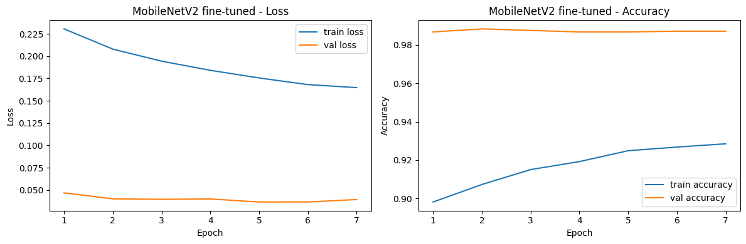
Screenshot 2. Fine-tuned MobileNetV2 learning curves from the built-in TensorFlow pipeline.
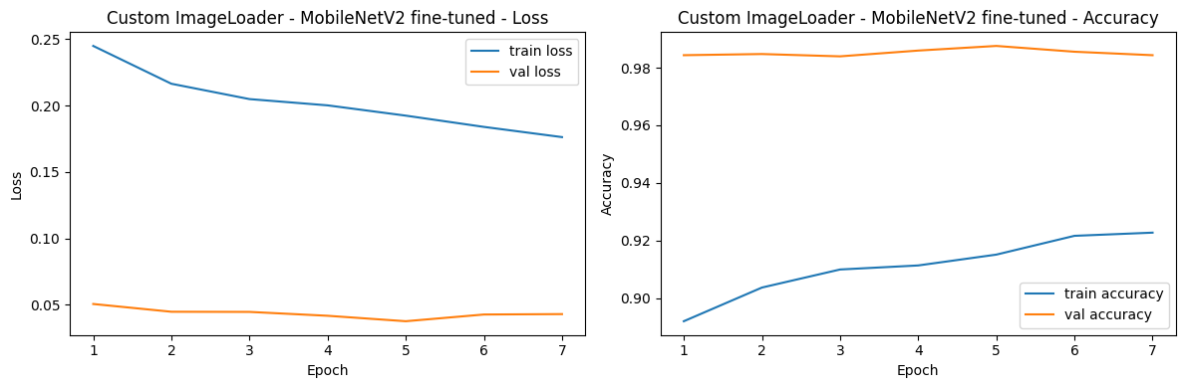
Screenshot 3. Fine-tuned MobileNetV2 learning curves from the custom ImageLoader pipeline.

Conclusion
Best result: The highest test accuracy of 98.92% with test loss of 0.0351 was achieved using the integrated TensorFlow pipeline. With a test accuracy of 98.80% and a test loss of 0.0349, the custom ImageLoader likewise demonstrated strong performance.
Overall, transfer learning was successful because MobileNetV2 has previously learned useful visual elements from ImageNet, including edges, forms, textures, and object patterns. Rather than building a CNN from scratch, the pretrained model provided the classifier with a stronger starting point and increased training efficiency. Following the initial training stage, the upper layers of MobileNetV2 were fine-tuned to allow the model to better match its learnt features to the cats-vs.-dogs dataset. This improved the model's ability to recognize distinctions between the two classes while retaining the benefits of the pretrained backbone. The custom ImageLoader showed how the data pipeline can be created manually. It illustrated how to load image files from folders, apply labels, shuffle across epochs, augment, arrange into batches, and send them into the model without relying solely on Keras helper methods.

